Task No: 7. Utilizing ‘Functions’ concepts in Python Programming.
7.a. You are developing a small Python script to analyze and manipulate a list of student grades for a class project. Write a Python program that satisfies the above requirements using the built-in functions print(), len(), type(), max(), min(), sorted(), reversed(), and range().
PROGRAM

def analyze_student_grades():
# Sample data
student_names = ["Alice", "Bob", "Charlie", "Diana"]
student_grades = [85, 92, 78, 90]

# 1. Print a welcome message
print("Welcome to the Student Grades Analyzer!\n")

# 2. Determine and print the number of students
num_students = len(student_names)
print("Number of students:", num_students)

# 3. Print the type of the student names list and the grades list
print("\nType of student_names list:", type(student_names))
print("Type of student_grades list:", type(student_grades))

# 4. Find and print the highest and lowest grade
highest_grade = max(student_grades)
lowest_grade = min(student_grades)
print("\nHighest grade:", highest_grade)
print("Lowest grade:", lowest_grade)

# 5. Print the list of grades sorted in ascending order
sorted_grades = sorted(student_grades)
print("\nSorted grades:", sorted_grades)

# 6. Print the list of grades in reverse order
reversed_grades = list(reversed(sorted_grades))
print("Reversed grades:", reversed_grades)

# 7. Generate and print a range of grade indices from 1 to the number of students
grade_indices = list(range(1, num_students + 1))
print("\nGrade indices from 1 to number of students:", grade_indices)

# Run the analysis
analyze_student_grades()

OUTPUT

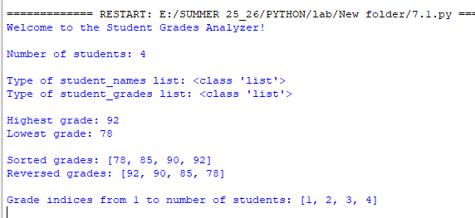

7.b. You are tasked with creating a small calculator application to help users perform basic arithmetic operations and greet them with a personalized message. Your application should perform the following tasks: addition, subtraction, multiplication, division.
PROGRAM

def add(a, b):
return a + b
def subtract(a, b):
return a - b
multiply = lambda a, b: a * b
divide = lambda a, b: a / b if b != 0 else "Error: Division by zero"

# Regular function for greeting
greet = lambda name: f"Hello, {name}! Welcome to the program."

def main():
# Demonstrating the use of lambda functions
num1 = int(input("enter num1:"))
num2 = int(input("enter num2:"))

print("Arithmetic Operations:")
print("Sum of", num1, "and", num2, ":", add(num1, num2))
diff=subtract(num1, num2)
print("Difference between", num1, "and", num2, ":", diff)
if diff< 0:
print("The difference is negative!")
elif diff==0:
print("The difference is Zero!")
else:
print("The difference is Positive!")

print("Product of", num1, "and", num2, ":", multiply(num1, num2))
print("Quotient of", num1, "and", num2, ":", divide(num1, num2))
# Greeting the user
user_name = "Alice"
print("\nGreeting:")
print(greet(user_name))

# Run the main function
if __name__ == "__main__":
main()

OUTPUT

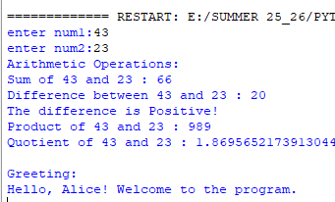

7.C

Write a Python program to create a function that takes a string as input and returns its reversed form. Hint: Use a recursive function.

PROGRAM
# Recursive function to reverse a string
def reverse_string(s):
if len(s) == 0: # base case
return s
return reverse_string(s[1:]) + s[0]

# Test cases
print("Reverse of 'hello' =", reverse_string("hello"))
print("Reverse of 'python' =", reverse_string("python"))
print("Reverse of 'recursion' =", reverse_string("recursion"))

OUTPUT

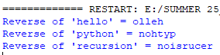

7.d
Write a Python program to analyze a list of student grades using functional programming techniques. Use lambda functions with map to modify or scale the grades, filter to select students above a certain threshold, reduce to calculate the total or average grade, and sort or sorted to arrange the grades in order. Display the results at each step, including the original grades, filtered grades, sorted grades, and the total or average.

PROGRAM

from functools import reduce

# Sample data
student_names = ["Alice", "Bob", "Charlie", "Diana"]
student_grades = [65, 72, 58, 70]

print("Original Grades:")
print(list(zip(student_names, student_grades)))

# 1. Scale grades using map and lambda (e.g., add 20 internal points to each grade)
scaled_grades = list(map(lambda x: x + 20, student_grades))
print("\nScaled Grades (+20 points):")
print(list(zip(student_names, scaled_grades)))

# 2. Filter students with grades above 90 using filter and lambda
high_achievers = list(filter(lambda x: x > 90, scaled_grades))
print("\nStudents with grades above 90:", high_achievers)

# 3. Calculate total and average using reduce
total = reduce(lambda a, b: a + b, scaled_grades)
average = total / len(scaled_grades)
print("\nTotal of scaled grades:", total)
print("Average of scaled grades:", average)

# 4. Sort grades in ascending order using sorted and lambda
sorted_grades = sorted(scaled_grades)
print("\nSorted Grades (Ascending):", sorted_grades)

# 5. Sort grades in descending order using sorted and lambda
sorted_desc = sorted(scaled_grades, reverse=True)
print("\nSorted Grades (Descending):”, sorted_desc )

OUTPUT

